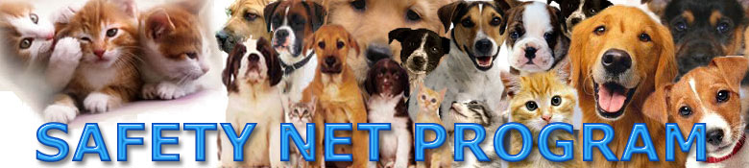

LOW COST VETERINARY SERVICES
(only for NY City Animal Care & Control referred clients)

If your pet animal is coughing, wheezing, not eating, not urinating, not defecating, or not moving much it is probably sick. DO NOT WAIT. The longer you delay going to the veterinarian the more expensive treatment becomes and Safety Net will not be able to afford the cost to cure your lovely animal. If you delay even a few days the probability that the animal will die increases by a lot. If you need low cost Spay and Neuter for your pet animal call Safety Net at 718-544-PETS(7387) anytime during the weekends (anytime Saturday or Sunday).

Fortunately, Animal Care & Control of New York City has one of the most innovative programs for pet guardians and their beloved animals in the country, called the Safety Net Program. Many free and low-cost support services, including super low cost veterinary services, are available from the Safety Net Program. A color brochure is available upon asking or you can visit the program online at www.718544pets.org and read about the many ways Safety Net can help you and your beloved animal and save you hundreds of dollars at the same time.

How to get super low-cost veterinary services:

- Either call 212-788-4000 or go to New York City’s Animal Care & Control shelters, drop off facilities, or customer service and tell them your pet animal needs low cost veterinary services. They will give you a six digit P number and a six digit A number. Write these numbers down.
- Call one of the following veterinarians and tell them that Garo from the Safety Net Program at New York City Animal Care & Control referred you and that you would like to make an appointment to bring your animal to the veterinarian. Make the first appointment available. DO NOT DELAY!
- Some veterinarians are close to subways and/or buses, others require a car. If you have a medium or large size dog you must ask friends, neighbors, or relatives to do you and you lovely pet animal a favor this one time by driving you and your pet to the veterinarian. Subways and buses do not allow normal size dogs.
- As you probably know most veterinary visits cost between $150-450. Our super low-cost veterinarians will try to treat you animals at much, much lower cost than that. You must bring at least $85 with you in cash or credit or debit card so our veterinarians can try to cure the animal.You must have at least $85, which covers the reduced visit charge and some left over for minor therapies..
- If you already took your animal to other veterinarians outside of Safety Net ask the other veterinarian for copies of the medical records and copies of any blood tests and X-rays, if applicable. Some veterinarians will only give records to another veterinarian. So when you make your appointment to see the Safety Net veterinarian tell them that you are going to have the previous veterinarian fax over the medical records before your scheduled appointment day. By law, veterinarians MUST give copies of your medical records when you ask for them, but they may charge you about $20 for copies of X-Rays or ask for a deposit to borrow the original X Rays.
- When you see the Safety Net veterinarian tell him that Garo from the Safety Net Program at New York City Animal Care & Control referred you. This is very important so that the Safety Net Veterinarian can charge you the super low cost prices. If the Safety Net veterinarian tells you it will cost much more than what you can afford call Garo at Safety Net at 718-544-PETS from the Safety Net veterinarian’s office when you and your pet animal are in his examination room. If you do not have a cel phone the Safety Net veterinarian will let you use his phone if you ask politely.
- After your beautiful animal has been treated by the Safety Net veterinarian call New York City Animal Care & Control’s customer service at 212-788-4000 and give them your A # and P # and tell them the results of your visit to the Safety Net veterinarian. THIS IS VERY VERY IMPORTANT SO YOU CAN CONTINUE TO RECEIVE LOW COST AND FREE SERVICES IN THE FUTURE
- Continue to enjoy the companionship of your loveable, loyal, animal friend!

Safety Net Veterinarian Locations

Manhattan, Queens, Brooklyn, Long Island

